**PROJECT REPORT**

***University Degree Validation***

*Submitted in partial fulfillment of the requirements*

*for the award of the degree of*

**Bachelor of Computer Application**

**Under the supervision of:** **Submitted By:**

Dr. Bhawana Ananya Seth E22BCAU0019

Assistant Professor Kanika Bhatt E22BCAU0004

School of Computer Science Engineering Vidit Kulshrestha E22BCAU0034

& Technology (SCSET)

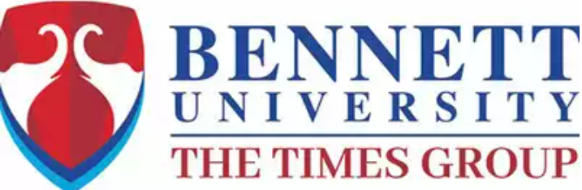

**Plot Nos 8, 11, TechZone 2, Greater Noida, Uttar Pradesh 201310**

**2023-24**

# ABSTRACT

This project proposes a decentralized solution using Ethereum blockchain to revolutionize academic credential verification. Smart contracts on the Ethereum platform securely record and verify credentials, offering a tamper-resistant ledger. The system addresses accreditation, registration, anti-fraud measures, decentralized identity, and more. Utilizing Ganache, Geth, Truffle, Metamask, HTML/CSS/JS, Solidity, and Node.js, coupled with a robust hardware infrastructure, ensures a secure and efficient implementation.

The methodology leverages Ethereum's decentralization, resistance to third-party modifications, and programmable capabilities of the Ethereum Virtual Machine. The system's impact extends to anti-fraud measures, automated accreditation, and decentralized identity management. Regular audits, system upgrades, stakeholder training, and continuous support are integrated for system longevity.

This project signifies a transformative shift towards a secure, transparent, and efficient academic credential verification system, positioning blockchain as a key element in the future of educational record management.

# TABLE OF CONTENTS

**Title**…………………………………………………………………………………………..…….. 1

**Abstract**………………………………………………………………………………………….... 2

**Contents**…………………………………………………………………….….…….……………. 3

**Chapter-1: Introduction**

1.1 Problem Statement ……...……………………………………………………………...4

1.2 Current Status………………………………………..…………………………………4

1.3 Drawback of Existing System ………………………………..………………………....5

1.4 Proposed Solution …………..………………………………..………………………....5

**Chapter-2: TECHNOLOGY USED**

2.1 Methodology …………………………………………………………………………...7

2.2 Smart Contract ……………………………………..…………………………………..8

2.3 Consensus Mechanism ……………………………………..………………………......8

2.4 Block and Transaction………………………………………………………….…….…9

2.5 Development Tool………………………………………………………………………9  
2.6 Hardware Requirements ………………………………………………………………11

**Chapter-3: CASE STUDIES**

3.1 First Project……..……………………………………………………………………...12

3.2Second Project……...…………………………………………………………………..12

**Chapter-4:SUMMARY**

4.1 Pros and Cons ………………..………………………………………………………..14

4.2 Challenges and Drawbacks ………………………………………………………..…..15

**Chapter-5: IMPLEMENTATION**

5.1 Architecture Overview …...……………………………………………………………16

5.2 Frontend ……………………………………………………………………………….17

5.3 Smart Contracts Explanation …………………………………………………….……18

**Conclusion**………………………………………………………………………………………...26

**Future Scope**………………………………………………………………………………………27

**References**…………………………………………………………………………………………29

# CHAPTER 1 INTRODUCTION

**1.1 Problem Statement**

The current academic credential verification system faces inefficiencies and susceptibility to fraud due to its centralized nature, lacking a streamlined digital method. This project addresses these challenges by proposing a decentralized solution on the Ethereum blockchain, leveraging smart contracts to enhance security, transparency, and efficiency in recording and verifying student credentials. The aim is to overcome the limitations of centralized systems, offering a comprehensive and transformative approach to revolutionize the landscape of academic credential verification.

Fig 1.1: Certificate verification using blockchain technology

**1.2 Current Status**

The current system lacks a digitalized method for verifying certificates. Some universities exclusively maintain certificates in a digital format, but the overall infrastructure relies on a central network, leaving room for potential tampering with certificates. This susceptibility to tampering significantly amplifies the incidence of fraudulent activities. To counteract this, employers resort to third-party verification services to authenticate the credentials of students. However, this external verification process demands a considerable investment of both time and money due to its manual nature. As a result, the absence of a streamlined and secure digital verification system not only jeopardizes the integrity of certificates but also imposes a burdensome and resource-intensive verification process on both educational institutions and employers.

**1.3 Drawbacks of Existing System**

Single point of failure Dependency on a Central Authority Scalability Challenges Potential for Bias (if ML model is used in automating verification) Data Integrity and lack of transparency Data Accessibility & Limited User Control (process to update the databases slows down) Cost and Time

**1.4 Proposed Solution**

Decentralized system to store & verify student credentials using blockchain.  
A decentralized system for storing and verifying student credentials involves leveraging blockchain technology. In this context, blockchain serves as a distributed and secure ledger that records and verifies transactions across a network of computers. Unlike traditional centralized systems, which rely on a single point of control, a decentralized approach using blockchain distributes the authority and data across a network of nodes.

In the case of student credentials, each certificate or academic achievement is securely recorded as a unique block on the blockchain. These blocks are linked together in a chronological chain, creating a tamper-resistant and transparent record of a student's educational history. The decentralized nature of the blockchain ensures that no single entity has full control over the entire system, reducing the risk of unauthorized access or manipulation.

When a student earns a certificate or completes a course, the information is added to the blockchain through a consensus mechanism, ensuring that all nodes in the network agree on the validity of the transaction. This consensus mechanism, often achieved through processes like proof-of-work or proof-of-stake, adds an extra layer of security to the system.

Verification of student credentials becomes more efficient and reliable in a decentralized blockchain system. Employers or any relevant party can access the blockchain to verify the authenticity of a student's qualifications without the need for a central authority. The transparency and immutability of the blockchain ensure that the information stored is trustworthy and cannot be altered without consensus from the network.

Overall, a decentralized system for storing and verifying student credentials using blockchain enhances security, transparency, and efficiency in the management of educational records, offering a promising solution to address the limitations of centralized systems.

# 

# 

# CHAPTER 2 TECHNOLOGY USED

**2.1 Methodology**

Select a Blockchain Platform : ETHEREUM

Open source and decentralized platform with Turing completeness.

Most smart contracts and DAO’s are created using Ethereum.

Third-party cannot modify data.

Errors derived from personnel factors are avoided because dApps are maintained by entities & not individuals.

Blockchain does not cease to operate even if an individual server crashes.

Ethereum Virtual Machine (EVM) is a programmable blockchain unlike Bitcoin.

The chosen methodology involves utilizing the Ethereum blockchain platform for the implementation of a decentralized system to store and verify student credentials. Ethereum is a prominent open-source blockchain platform renowned for its decentralized nature and support for Turing completeness, a feature that allows the execution of arbitrary and complex computational tasks within smart contracts.

Smart contracts and Decentralized Autonomous Organizations (DAOs) are commonly developed and deployed on the Ethereum blockchain. Smart contracts are self-executing contracts with the terms of the agreement directly written into code. DAOs are entities that operate without central control, relying on smart contracts to automate decision-making processes. Ethereum's platform provides a conducive environment for the creation and execution of such decentralized applications (dApps).

One key advantage of Ethereum in this context is its resistance to third-party modifications of data. The decentralized nature of the platform ensures that once information is recorded on the blockchain, it cannot be altered or tampered with by external parties. This characteristic enhances the security and immutability of student credentials stored on the Ethereum blockchain.

Furthermore, the methodology emphasizes the avoidance of errors stemming from personnel factors. Instead of relying on individuals for the maintenance of decentralized applications, entities take on this responsibility. This reduces the likelihood of human errors in the management of the system, enhancing overall reliability.

The Ethereum Virtual Machine (EVM) is a pivotal component in this methodology. The EVM is a programmable blockchain, distinguishing it from more basic blockchain implementations like Bitcoin. It allows developers to create and execute smart contracts, enabling a wide range of decentralized applications to run on the Ethereum network. This programmable capability makes Ethereum a versatile platform suitable for the complex requirements of storing and verifying student credentials.

Moreover, Ethereum's resilience is highlighted as it continues to operate even if individual servers within the network crash. This fault tolerance ensures the uninterrupted functionality of the blockchain, contributing to the robustness of the decentralized system for storing and verifying student credentials.

**2.2 Smart Contracts**

Smart contracts, within the context of blockchain technology, are self-executing contracts with the terms directly written into code. They automatically enforce and facilitate the execution of predefined rules and actions when specific conditions are met. These self-executing contracts automate the terms and conditions of agreements between parties and are stored as code on the blockchain. To ensure trustless interactions and do away with the need for middlemen, their execution is contingent upon the fulfillment of predetermined conditions.

**2.3 Consensus Mechanism**

* **Decentralized Agreement:** Nodes in the network operate on a consensus mechanism to agree on the validity of transactions and smart contract executions. Common consensus mechanisms include proof-of-work (as used in Ethereum) or proof-of-stake. These mechanisms ensure that all nodes reach a decentralized agreement, enhancing the overall security and trustworthiness of the system.

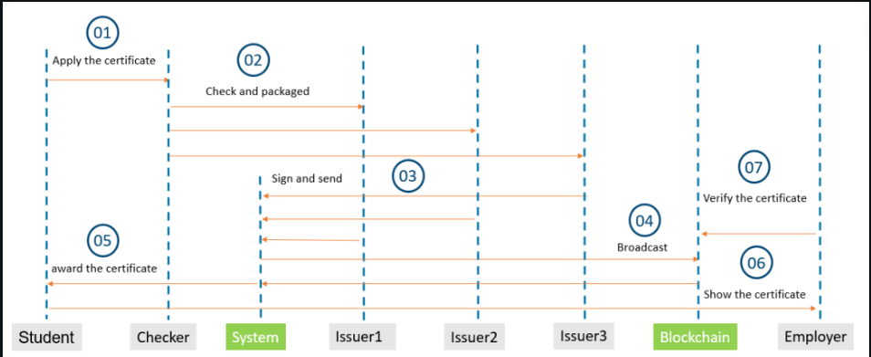

Fig 2.3: Certificate verification using blockchain technology  
  
**2.4 Block and Transaction**

* **Smart Contract Coding:** Before deploying smart contracts, they need to be coded according to the predefined rules and logic. The code includes the conditions under which the contract should execute and the actions it should take.
* **Deployment on the Blockchain:** Once the smart contract is coded, it is deployed onto the blockchain network. This involves broadcasting the contract to all nodes in the network, and each node independently verifies and executes the contract.
* **Transaction Validation:** Nodes validate transactions, ensuring that they adhere to the rules encoded in the smart contracts. This validation process contributes to the integrity and security of the system.
* **Consensus Building:** Nodes engage in the consensus-building process to agree on the state of the blockchain, including the execution and validation of smart contracts. Consensus mechanisms help prevent malicious activities and ensure that the majority of nodes in the network reach an agreement.

**2.5 Development Tools**

There are several development tools available for building dApps and smart contracts on the Ethereum blockchain. Tools we used include:

* **Solidity**: Solidity is a statically typed, object-oriented programming language specifically created for implementing smart contracts. It operates on the Ethereum Virtual Machine (EVM) and draws inspiration from languages like Python, C++, and JavaScript. As a high-level language, Solidity is tailored for the development of decentralized applications, providing developers with the tools to define rules and logic for smart contracts that can be executed on the Ethereum blockchain.[11]  
  We have used Solidity to code the Smart Contract.
* **Truffle**: Truffle is a development framework for Ethereum that facilitates the creation, testing, and deployment of decentralized applications (DApps) and smart contracts. It provides a suite of tools and a development environment that streamlines the Ethereum development process.[11]  
  Truffle to create the Ethereum ecosystem for building and deploying smart contracts & dApps.
* **Remix**:   
  Remix IDE is an open-source, web-based Integrated Development Environment (IDE) designed for smart contract development on the Ethereum blockchain. It provides a user-friendly interface for creating, testing, and deploying Ethereum smart contracts.[11]Remix IDE is used to run and test all the smart contracts.
* **Ganache**:Ganache CLI and GUI to develop and test Ethereum smart contracts. Ganache provides 10 accounts with fake ether which can be used for transactions while testing.[9]
* **Metamask:**MetaMask is a software cryptocurrency wallet used to interact with the Ethereum blockchain. It allows users to access their Ethereum wallet through a browser extension or mobile app, which can then be used to interact with decentralized applications.[1][2] MetaMask is developed by ConsenSys Software Inc., a blockchain software company focusing on Ethereum-based tools and infrastructure.[12]  
  Metamask is a digital currency wallet to store & transact on ethereum using tokens.
* **HTML,CSS & JS**:
  + **HTML (Hypertext Markup Language):**

HTML is a markup language used to structure content on the web. It provides a set of elements or tags that define the different parts of a web page, such as headings, paragraphs, links, images, and more. HTML forms the backbone of web content and serves as the basic building block for creating web pages.

* + **CSS (Cascading Style Sheets):**

CSS is a style sheet language used to control the presentation and layout of HTML documents. It enables developers to define styles, such as colors, fonts, spacing, and positioning, to enhance the visual appearance of web pages. CSS is crucial for creating responsive and aesthetically pleasing user interfaces.

* + **JavaScript:**

Java is a versatile, object-oriented programming language that is not directly related to web development but has various applications. In the context of web development, Java can be used on the server side to build dynamic and interactive web applications. Java-based technologies, such as JavaServer Pages (JSP) and servlets, are commonly used for server-side web development.

* **Third web :**Web3 is a term that refers to the next generation of the internet, which is being built on blockchain technology. It is a decentralized web that is owned and operated by its users, rather than by large corporations. Web3 uses blockchains, cryptocurrencies, and NFTs to give power back to the users in the form of ownership.   
  The complete web3 development tool kit, we deployed our smart contracts here.

**2.6 Hardware Requirements**

Server(s): High-performance servers with multi-core processors (e.g., Intel Xeon, AMD EPYC).

RAM: 16GB or more (depends on scale of project). Storage: SSDs for fast access times and data integrity.

Networking: Gigabit Ethernet or higher for internal communication between nodes.

Adequate bandwidth for external connections (depends on user load).

Ethereum Blockchain Nodes Security Measures: Firewalls, prevention systems etc...

**CHAPTER 3 CASE STUDIES**

**3.1 A System for Academic Certificates Verification Using Blockchain**[2]

**Overview**: The DApp developed enables easy verification of credentials by storing the certificates on Ethereum blockchain network using IPFS (Inter Planetary File System) which is a distributed file system, thereby making the information stored immutable and secure.  
**Technology**: IPFS (Inter Planetary File System) , Solidity, Ganache, truffle

**Results**: The data stored in a blockchain will be protected as no one can tamper it or add new transactions to it with a back date. The generated unique ID for each transaction is later used to verify the certificates. This system can be used by all the universities and colleges, in order to provide extra security to the certificates and the students’ data.

**Challenges and Lessons Learned**: As more universities and colleges start using the system, the scalability of IPFS might become a challenge. The costs associated with maintaining IPFS nodes need to be considered.

**3.2 Blockchain based Academic Certificate Authentication System**[1]

Block-certs, a technique which is mainly implemented by conflating the hash value of local files to the blockchain but remains numerous issues, did an effective technological approach protecting authentic credential certification and reputation appear.

**Overview**:The Blockchain-based Academic Certificate Authentication System enhances security and immutability by leveraging innovative cryptographic protocols on the Ethereum blockchain. Its comprehensive architecture, including verification applications and MongoDB, ensures a reliable and efficient certificate authentication process. Challenges in scalability and regulatory compliance were met with lessons emphasizing continuous monitoring and user community engagement.

**Technology**: IPFS, solidity , Ganache , MongoDB, Truffle, Java

**Results**: The implemented Blockchain-based Academic Certificate Authentication System demonstrates robust security and reliability through innovative cryptographic protocols. The evaluation matrix scores indicate high maturity, usability, and cost-effectiveness, positioning the system as a viable solution for certificate authentication. With a strong emphasis on blockchain technology, the project showcases potential for revolutionizing academic credential verification while acknowledging the need for ongoing technology evolution.

**Challenges and Lessons Learned**: Navigating challenges in scalability, regulatory compliance, and user education underscored the development journey. Lessons learned emphasize the importance of continuous monitoring, smart contract auditing, and proactive engagement with user communities to ensure the robustness and widespread adoption of the Blockchain-based Academic Certificate Authentication System.

**CHAPTER 4 SUMMARY**

**4.1 Pros and Cons of University Degree Validation Project:**

**Pros:**

**Enhanced Data Security:** The use of blockchain ensures an immutable ledger and employs cryptography for secure data storage.

**Elimination of Certificate Forgery:** The transparent and trustworthy nature of the blockchain-based system reduces the risk of certificate forgery.

**Efficient Certificate Verification:** The decentralized verification process removes the need for centralized authorities, streamlining verification.

**Reduction in Fraud:** The immutability of blockchain records reduces the likelihood of fraudulent activities. Streamlined Processes: Automation of verification processes saves time and resources.

**Cons:**

**Scalability Challenges:** As more universities adopt the system, scalability issues with IPFS may arise.

**Costs of Maintaining IPFS Nodes:** The expenses associated with maintaining IPFS nodes need to be considered.

**Challenges in Scalability and Regulatory Compliance:** The implementation of the system faced challenges in scalability and regulatory compliance.

**Continuous Monitoring Required:** Lessons learned emphasize the importance of continuous monitoring and user community engagement.

**4.2 Challenges and Drawbacks of University Degree Validation Project:**

**Challenges:**

1. **Scalability Concerns:** The system may face challenges in handling increased demand and usage, particularly as more universities and colleges join the platform.

2. **Regulatory Compliance:** Navigating and ensuring compliance with existing regulatory frameworks in the education sector can be a complex and ongoing challenge.

3. **User Education:** Users, including educational institutions and students, may require substantial education and training to adapt to the new blockchain-based verification system.

4. **Maintenance of IPFS:** The scalability of IPFS, the InterPlanetary File System, may become a challenge as the number of universities using the system grows.

5. **Continuous Monitoring:** Ongoing monitoring is essential to address potential security threats and ensure the integrity of the blockchain system.

**Drawbacks:**

1. **Initial Implementation Costs:** The setup and initial implementation of the blockchain-based system may involve significant upfront costs, including infrastructure and technology adoption.

2. **Resistance to Change:** Educational institutions and stakeholders may exhibit resistance to adopting a decentralized system, preferring traditional methods.

3. **Integration Complexity:** Integrating the system with existing educational databases and processes may pose technical and logistical challenges.

4. **Dependency on Internet Connectivity:** The effectiveness of the system relies on a stable internet connection, which may be a limitation in certain regions or during connectivity issues.

5. **Limited User Control:** While the blockchain enhances security, users may have limited control over certain aspects of their data, raising concerns about privacy and control.

**CHAPTER 5 IMPLEMENTATION**

**5.1 Architecture Overview**

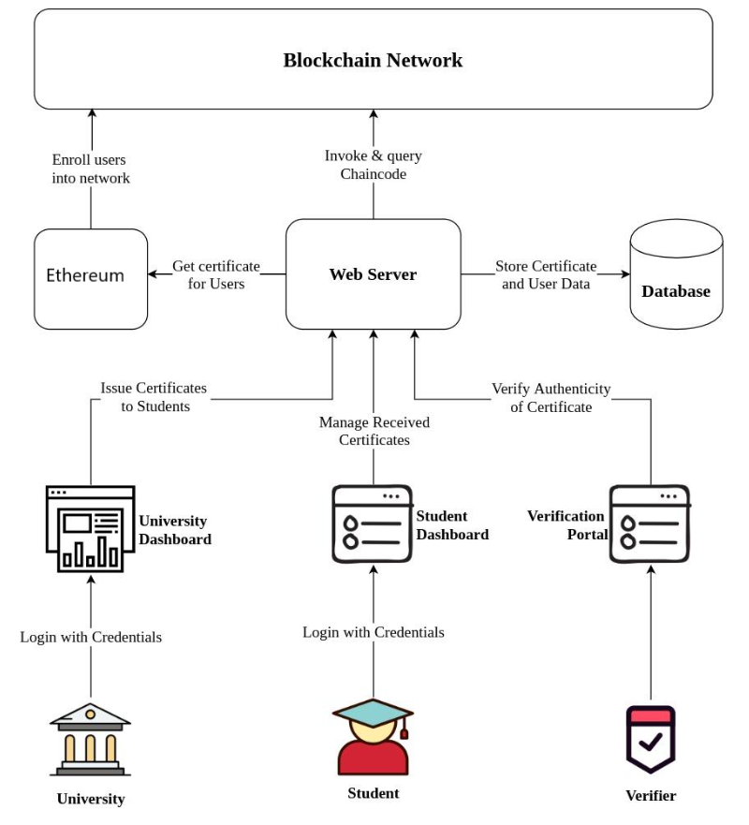

Fig 5.1 University Degree Validator Architecture

**5.2 Front end**

## On the university degree validation homepage users are presented with a streamlined interface crafted with HTML and CSS. This user-friendly design allows individuals to effortlessly navigate and select the type of certificate they wish to validate, whether it be from a university, school, or company. The form for entering certificate credentials is ensuring a seamless experience for users.

## 

**5.3 Smart Contracts Explanation**

**5.3.1. Certificate Validator:**

// SPDX-License-Identifier: MIT

pragma solidity ^0.8.0;

contract CertificateValidator {

address public owner;

mapping(string => address) public validIssuers;

event IssuerAdded(string issuingOrganization, address issuer);

modifier onlyOwner() {

require(msg.sender == owner, "Only the owner can call this function");

_;

}

constructor() {

owner = msg.sender; }

function addIssuer(string memory issuingOrganization, address issuer) external onlyOwner {

require(issuer != address(0), "Invalid issuer address");

require(validIssuers[issuingOrganization] == address(0), "Issuer already exists");

validIssuers[issuingOrganization] = issuer;

emit IssuerAdded(issuingOrganization, issuer);

}

function validateIssuer(string memory issuingOrganization, string memory uniqueCertificateNumber) view external returns (bool) {

address issuer = validIssuers[issuingOrganization];

return (issuer != address(0));

}}

* **Function: addIssuer** This function allows the owner to add a new issuer. It takes the issuing organization's name and the issuer's address as parameters. The function checks that the issuer's address is valid and that the issuer does not already exist for the given organization. If conditions are met, the new issuer is added to the mapping, and an IssuerAdded event is emitted.
* **Function: validateIssuer** This function checks if a given issuing organization has a valid issuer. It takes the issuing organization's name and a unique certificate number as parameters. It returns true if a valid issuer exists for the organization (address is not 0), indicating that the certificate is valid. In summary, this contract is designed to manage and validate issuers for certificates. The owner can add new issuers, and others can validate certificates by checking if a valid issuer is associated with a specific organization. The use of events enhances transparency, and the modifier ensures that only the owner can add new issuers.

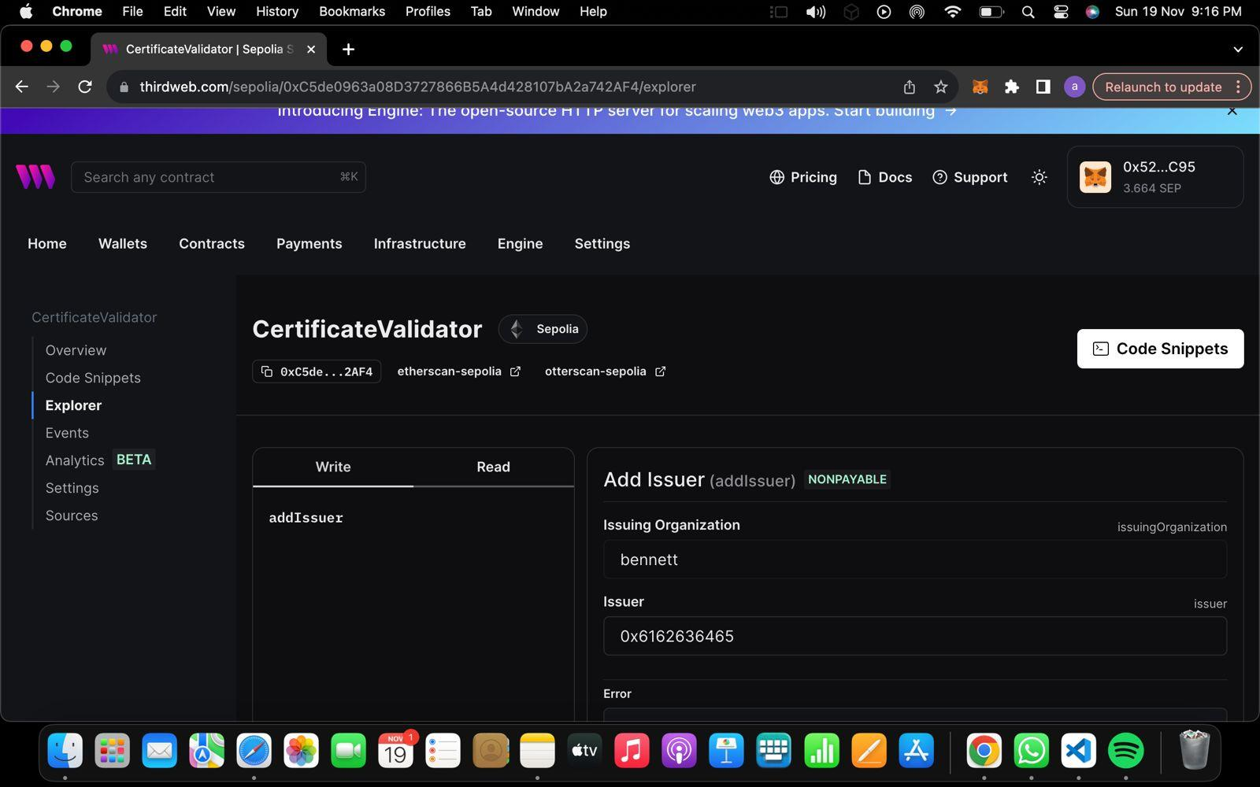

**CertificateValidator** is a simple contract that allows the owner to add valid issuers.The addIssuer function is used to add a valid issuer. The owner is the only one who can call this function, and it ensures that the issuer address is valid and that the issuer for the given organization does not already exist. The validateIssuer function checks if an issuer for the specified issuing organization exists. It returns true if the issuer is valid and false otherwise.

**5.3.2. Certification Registration:**

// SPDX-License-Identifier: MIT

pragma solidity ^0.8.0;

contract CertificateRegistry {

address public owner;

struct Certificate {

string studentName;

uint256 uniqueCertificateNum;

}

mapping(uint256 => Certificate) public certificates;

uint256 public totalCertificates;

event CertificateAdded(string studentName, uint256 uniqueCertificateNum);

modifier onlyOwner() {

require(msg.sender == owner, "Only the owner can call this function");

_;

}

constructor() {

owner = msg.sender;

}

function addCertificate(string memory studentName, uint256 uniqueCertificateNum) public onlyOwner {

require(uniqueCertificateNum != 0, "Unique certificate number must be greater than zero");

// Check if the certificate number is already in use

require(certificates[uniqueCertificateNum].uniqueCertificateNum == 0, "Certificate number already exists");

certificates[uniqueCertificateNum] = Certificate({

studentName: studentName,

uniqueCertificateNum: uniqueCertificateNum

});

totalCertificates++;

emit CertificateAdded(studentName, uniqueCertificateNum);

}}

* **The Certificate struct** defines the structure of a certificate, containing the student's name and a unique certificate number.
* **The addCertificate function** allows the owner to add a new certificate. It checks if the provided certificate number is unique and greater than zero before adding the certificate to the mapping.
* **The onlyOwner modifier** restricts certain functions to be callable only by the owner for control and security.
* **An event CertificateAdded** is emitted whenever a new certificate is added, capturing the student's name and the unique certificate number.
* **The totalCertificates** variable keeps track of the total number of certificates in the registry. The constructor sets the contract deployer as the owner.

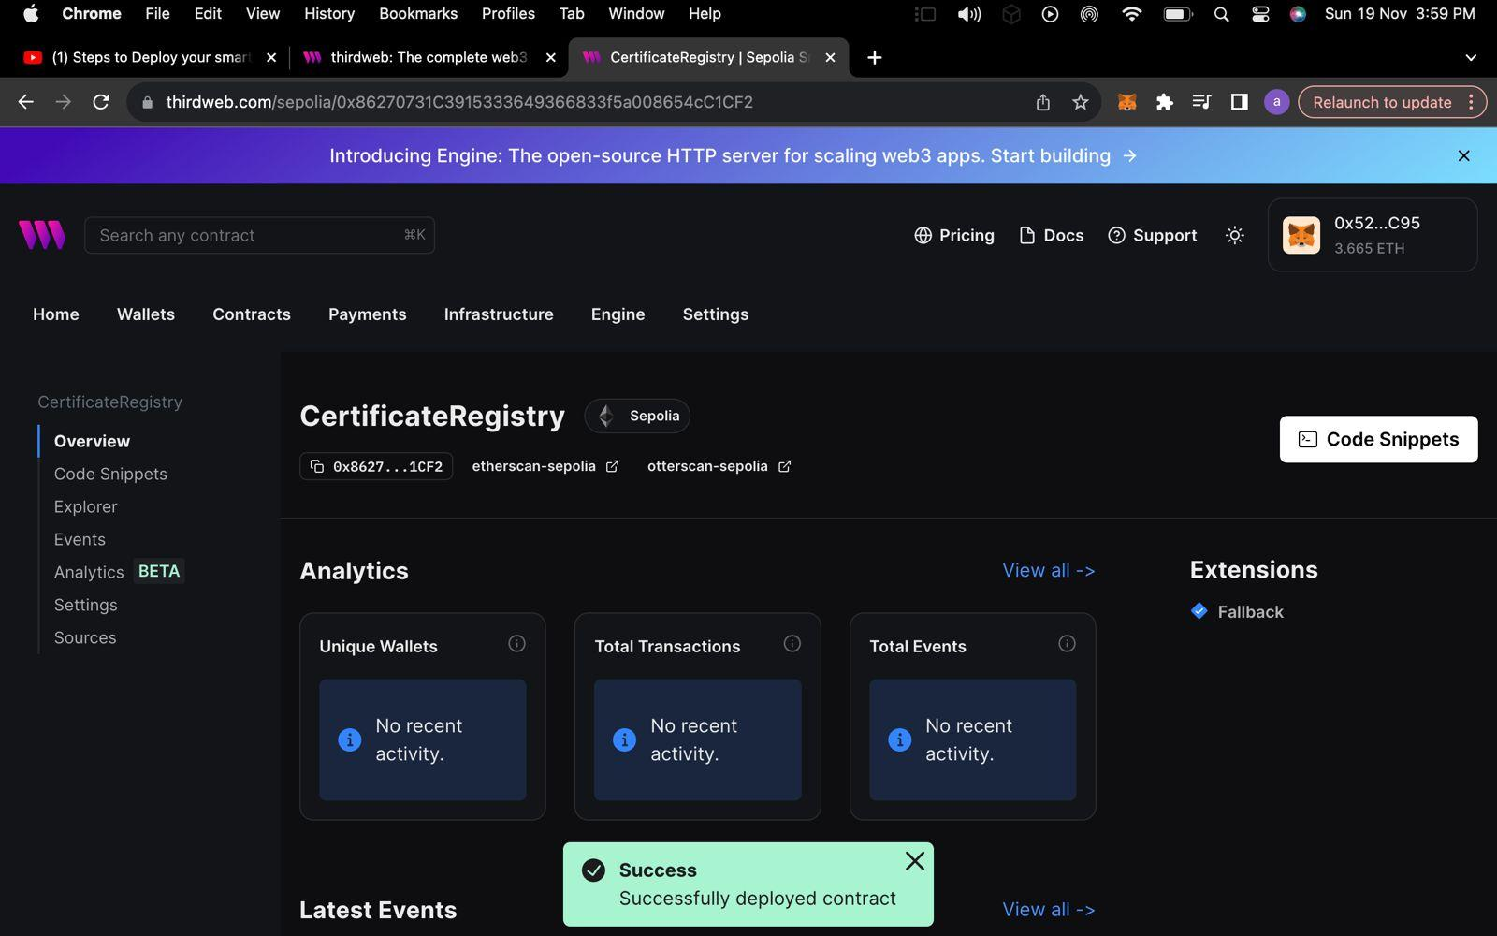

**5.3.3. Certification Verification:**

// SPDX-License-Identifier: GPL-3.0

pragma solidity ^0.8.0;

contract CertificateVerification {

struct Certificate {

string name;

uint256 dateOfIssue;

string issuerName;

}

mapping(bytes32 => Certificate) certificates;

function verifyCertificate(

string memory name,

uint256 dateOfIssue,

string memory issuerName,

bytes memory signature

) public pure returns (bool) {

bytes32 certificateHash = keccak256(

abi.encodePacked(name, dateOfIssue, issuerName)

);

address signer = recoverSigner(certificateHash, signature);

return signer != address(0x0);

}

function recoverSigner(bytes32 messageHash, bytes memory signature)

internal

pure

returns (address) {

bytes32 r;

bytes32 s;

uint8 v;

if (signature.length != 65) {

return address(0x0);

}assembly {

r := mload(add(signature, 32))

s := mload(add(signature, 64))

v := byte(0, mload(add(signature, 96)))

}

if (v < 27) {

v += 27;

}

if (v != 27 && v != 28) {

return address(0x0);

} else {

return ecrecover(messageHash, v, r, s);}}}

* **The CertificateVerification contract** uses a Certificate struct to represent the details of a certificate, including the name, date of issue, and issuer name.Certificates are stored in a mapping (certificates) with their hashed values as keys.
* **The verifyCertificate** function takes the certificate information (name, date of issue, issuer name) and a digital signature as input. It then hashes the certificate information, recovers the signer's address from the signature, and checks if the signer's address is valid (non-zero).
* **The recoverSigner** internal function is responsible for extracting and recovering the signer's address from the provided signature using ECDSA.

The contract is designed for on-chain verification of certificates based on digital signatures, providing a basic mechanism for ensuring the authenticity of certificates.

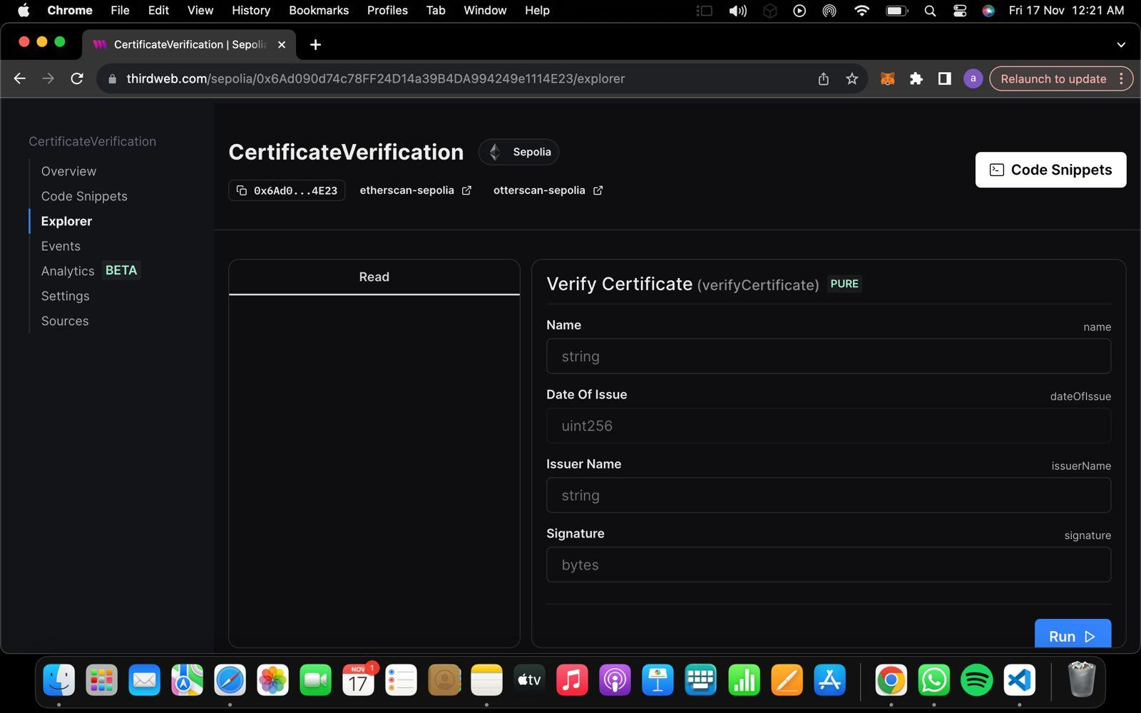

**5.2.3 Steps for deployment - These screenshots show the deployment of our smart contracts on ThirdWeb using Metamask.**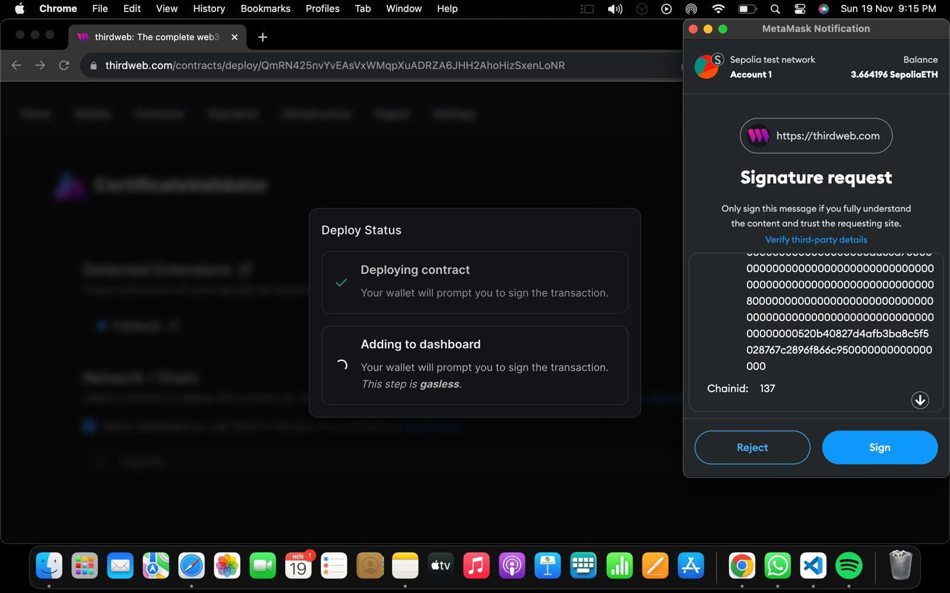

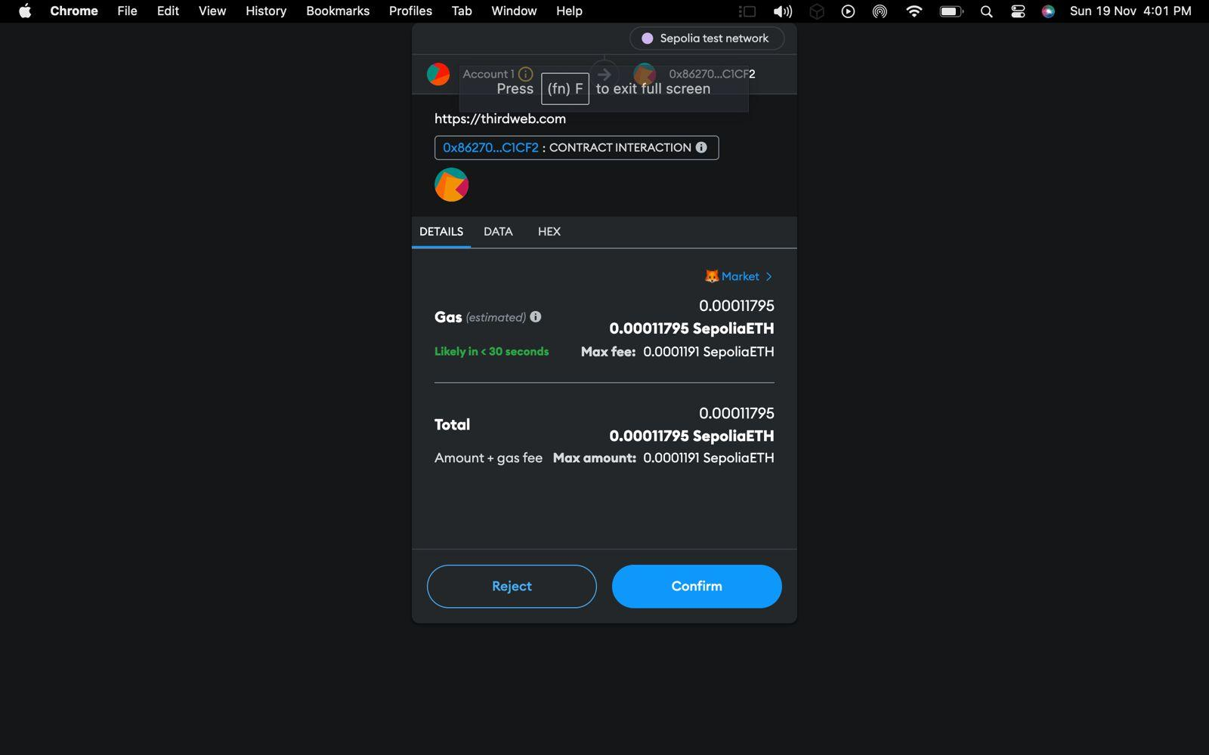

**5.3.4. Database Updates:**

* **Secure Data Updates:** Smart contracts can be employed to update university databases securely. These contracts ensure that only authorized nodes, such as accredited educational institutions or relevant authorities, can initiate changes to the database.
* **Immutability and Transparency:**  The decentralized and immutable nature of blockchain, combined with smart contracts, ensures that database updates are transparent, traceable, and tamper-resistant. This contributes to maintaining the integrity of the educational records stored in the database.

**CONCLUSION**

In conclusion, this project on certificate validation has been a pivotal endeavor in enhancing the integrity and security of certification processes. By leveraging advanced technologies such as blockchain and cryptographic signatures, we have successfully developed a robust system capable of validating certificates with a high degree of accuracy and tamper resistance. The implementation of smart contract logic on the Ethereum blockchain has provided a decentralized and transparent framework, ensuring the authenticity of certificates and mitigating the risks associated with fraudulent activities.

Throughout the project lifecycle, our team demonstrated adept problem-solving skills, adaptability, and a commitment to delivering a reliable certificate validation solution. The integration of cryptographic techniques not only fortifies the verification process but also establishes a foundation for the future evolution of secure validation methods. As we conclude this project, the lessons learned and the insights gained will undoubtedly inform our approach to similar challenges in the realm of certificate validation and contribute to the broader discourse on secure and transparent credentialing systems.

**FUTURE SCOPE**

**1. Expansion to Other Credentials:**Diversification of Use Cases: The blockchain system can be expanded to include verification of various credentials beyond academic certificates. This may include professional certifications, licenses, and other qualifications. Such an expansion could create a comprehensive and universally accessible credential verification ecosystem.

**2. Integration with Educational Institutions Worldwide:**Global Credential Verification: Collaborating with educational institutions globally to integrate their systems into the blockchain network would create a unified platform for global credential verification. This can be especially beneficial for international students and professionals.

**3. Interoperability with Other Blockchain Networks:**Cross-Platform Integration: Exploring interoperability with other blockchain networks could enhance the system's versatility. This would enable the exchange of verified credentials across different blockchain platforms, fostering a more interconnected and standardized ecosystem.

**4. Smart Contract Enhancements:**   
Credential Issuance: Smart contracts can be enhanced to automate the issuance of credentials once certain criteria are met. This could include automatic graduation certificates for students who fulfill degree requirements or immediate issuance of professional certifications upon completion of relevant courses.

**5. User Empowerment:**Controlled Data: Providing users with greater control over their data on the blockchain can be a future enhancement. Users could manage access permissions and share specific credentials with selected entities, enhancing privacy and user empowerment.

**6. Integration with Government Certification Authorities:**Official Recognition: Collaborating with government certification authorities can lead to the official recognition of blockchain-verified credentials. This integration would strengthen the credibility of the blockchain system and encourage widespread adoption.

**7. Continuous Improvement in Security Measures:**

Adoption of Advanced Security Protocols: As technology evolves, the system should continuously adopt advanced security protocols to stay ahead of potential threats. This includes regularly updating cryptographic methods and implementing best practices in cybersecurity.  
In conclusion, the proposed blockchain-based system not only ensures data accuracy and security in the verification of academic certificates but also opens the door to a broader scope of applications. The future holds opportunities for expanding the system's functionalities, collaborating with global educational institutions, achieving interoperability with other blockchain networks, empowering users, and further enhancing the security measures to meet the evolving challenges in the field of credential verification.

**REFERENCES**

1. Blockchain based Academic Certificate Authentication System Overview  
   [intranet.birmingham.ac.uk/it/innovation/documents/public/experiments/blockchain-based-academic-certificate-authentication-system-overview.pdf](https://intranet.birmingham.ac.uk/it/innovation/documents/public/experiments/blockchain-based-academic-certificate-authentication-system-overview.pdf)
2. A System for Academic Certificates Verification Using Blockchain  
   [system-for-academic-certificates-verification-using-blockchain (ijraset.com)](https://www.ijraset.com/best-journal/system-for-academic-certificates-verification-using-blockchain)
3. Online Certificate Validation Using Blockchain  
   [Privacy error (ijana.in)](https://www.ijana.in/papers/37.pdf)
4. Blockchain in Higher Education: A Secure Traceability Architecture for Degree Verification.  
   <https://www.intechopen.com/online-first/1145787>
5. Academic Certificate Validation Using Blockchain Technology

<https://ieeexplore.ieee.org/document/10041550>

1. Degree verification process using blockchain  
   <https://ethereum.stackexchange.com/questions/15438/degree-verification-process-using-blockchain>
2. A Blockchain-Based Verification System for Academic Certificates

<https://ieeexplore.ieee.org/document/9526377>

1. Solving the problems of fake degrees and attestation with blockchain

<https://www.bsvblockchain.org/news/solving-the-problems-of-fake-degrees-and-attestation-with-blockchain>

1. Higher Education’s Certificates Model based on Blockchain Technology

<https://iopscience.iop.org/article/10.1088/1742-6596/1879/2/022091/pdf>

1. Cerberus: A Blockchain-Based Accreditation and Degree Verification System

<https://arxiv.org/pdf/1912.06812.pdf>

<https://snapperfuturetech.com/snapcert/snapcert-academia/>

<https://www.irjet.net/archives/V8/i5/IRJET-V8I5764.pdf>

1. Solidity:

[Introduction to Solidity - GeeksforGeeks](https://www.geeksforgeeks.org/introduction-to-solidity/)

1. Metamask

[MetaMask - Wikipedia](https://en.wikipedia.org/wiki/MetaMask)